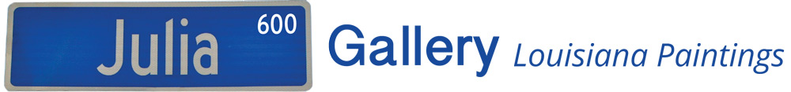

**MAY 2023**

**Title of Show: *Loose Living on The Bayou***

**Gallery 600 Julia 600 Julia Street  New Orleans 70130**

**504 895 7375; www.gallery600julia.com**

**Artist: Carol Hallock**

**Description: Painting in Bayou Lacombe on her pontoon boat, Carol plies her signature style of “loose realism”.**

**Opening Date: May 6, 2023 “Jammin’ on Julia” 5:00-9:00pm**

**Closing Date: May 31, 2023**